# CS 255 System Design Document Template

## UML Diagrams

### UML Use Case Diagram

### UML Activity Diagrams

1. Creating a new account

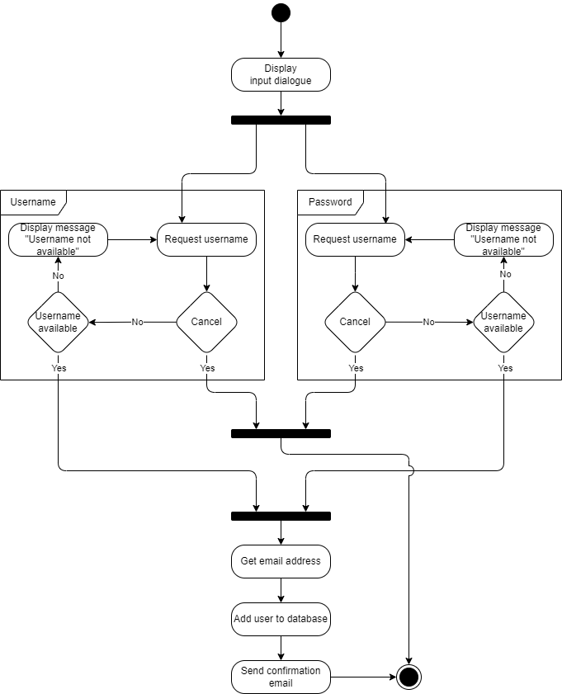

2. Making an appointment

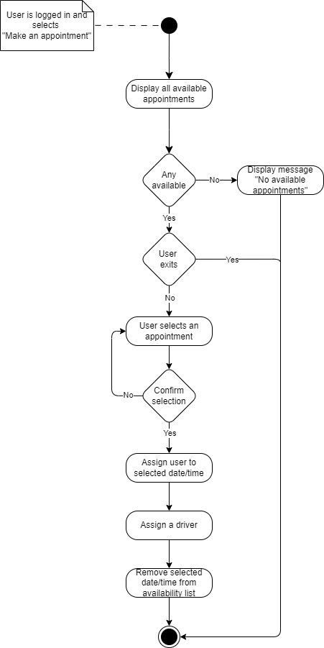

### UML Sequence Diagram

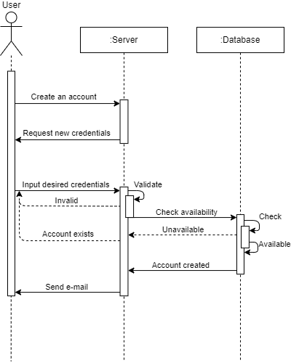

### UML Class Diagram

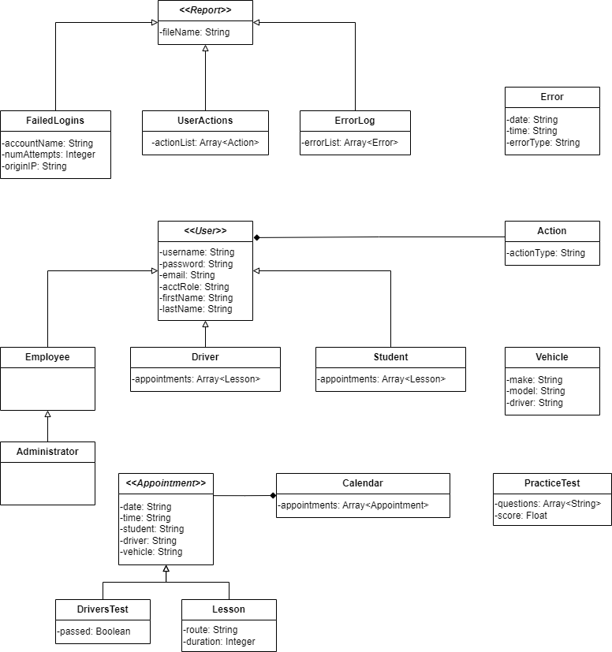

## Technical Requirements

* ***Technical Requirements***
  + **Hardware**
    - Client-side computer or mobile device
    - High-speed network adapter
    - Output devices:
    - Monitor/Display
    - Printer
    - Input Devices:
    - Keyboard
    - Mouse or touchscreen
  + **Software**
    - Linux operating system
    - Firewall and malware protection
    - Compression software for report archival
  + **Geographic Information**
    - 3rd party, off-site server
    - 3rd party cloud-based database